Adding a new user to the GIGAnet Database

1. Navigate to the **Administrator** page (accessible from the left-side menu). Once there, you should see this page (cropped image):

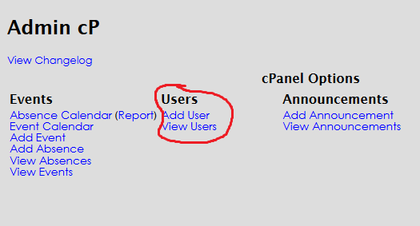

1. You can then either click on **Add User** or **View Users**.
   1. **Add User** lets you add a new user to the database. If the data specified already exists, it will not let you save (this prevents having duplicate entries).  
      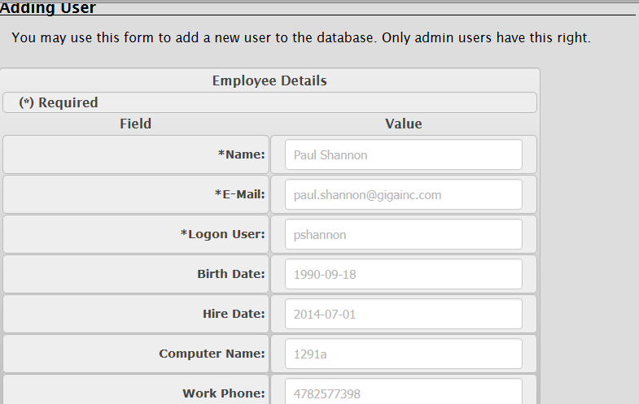
   2. **View Users** lists all users currently entered into the database. There are edit and delete icons by each one (clicking in the edit icon takes you straight to editing, but clicking on the delete option asks you to confirm it first, to prevent accidental deletion).  
      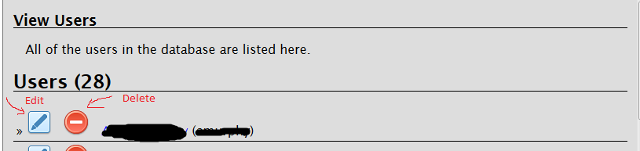  
      The data is blacked out for security purposes. You can also click on a user’s link here and view the entered information for them.